**Project Design Phase-II**

**Data Flow Diagram & User Stories**

|  |  |
| --- | --- |
| Date | 31 January 2025 |
| Team ID | LTVIP2025TMID36078 |
| Project Name | GrainPalette - A Deep Learning Odyssey In Rice Type Classification Through Transfer Learning |
| Maximum Marks | 4 Marks |

**Data Flow Diagrams:**

A Data Flow Diagram (DFD) is a traditional visual representation of the information flows within a system. A neat and clear DFD can depict the right amount of the system requirement graphically. It shows how data enters and leaves the system, what changes the information, and where data is stored.



**Example:** [**(Simplified)**](https://developer.ibm.com/patterns/visualize-unstructured-text/)

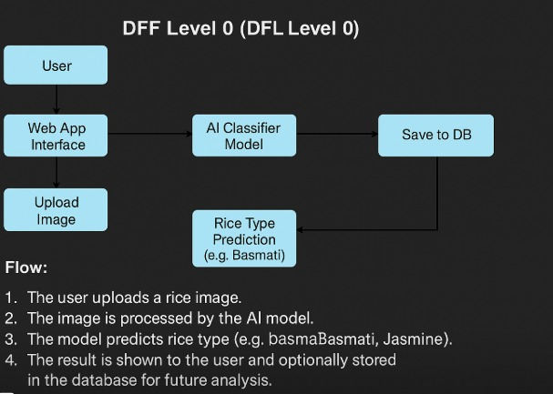

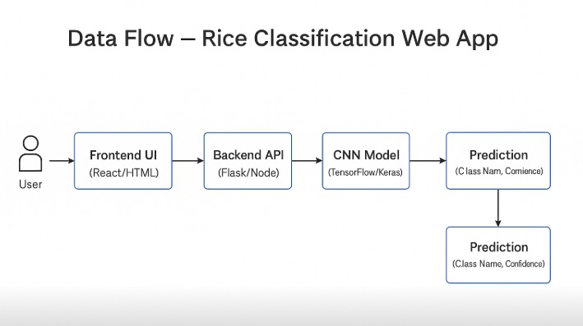

**User Stories**

Use the below template to list all the user stories for the product.

| **User Type** | **Functional Requirement (Epic)** | **User Story Number** | **User Story / Task** | **Acceptance criteria** | **Priority** | **Release** |
| --- | --- | --- | --- | --- | --- | --- |
| Customer (Mobile user) | Uploaded Function | USN-1 | As a user, I can upload an image of rice to get its type prediction | The image uploads and predictions is displayed correctly | High | Sprint-1 |
| Customer | Model Output | USN-2 | As a user, I can see the rice type result along with confidence score after upload | I see the rice type and confidence score clearly | High | Sprint-1 |
| Admin | Dataset Management | USN-3 | As a admin, I can upload new images to retain or improve the AI model. | Dataset uploads successfully | Medium | Sprint-2 |
| Customer | History/Records | USN-4 | As a user, I can view the history of my previous uploads and predictions. | I can view a list of my past predictions | Low | Sprint-3 |
| Developer/Admin | Model Accuracy Monitoring | USN-5 | As a developer, I can view performance metrics of the AI model after predictions. | Metrics such as accuracy, precision, recall are shown | Medium | Sprint-3 |